**LINUX COMMANDS**

Date- Display the current time in the given FORMAT, or set the system date.

Whereis- Locate the binary, source, and manual-page files for a command.

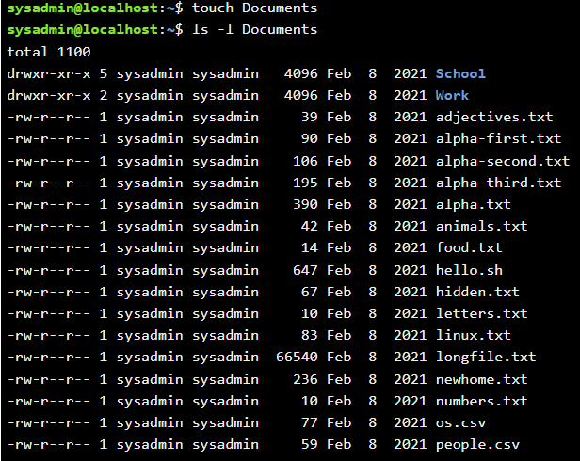Touch- Update the access and modification times of each FILE to the current time.

Glob- They allow you to specify patterns that match filenames in a directory.

Tar- Saves many files together into a single tape or disk archive, and can restore individual files from the archive.

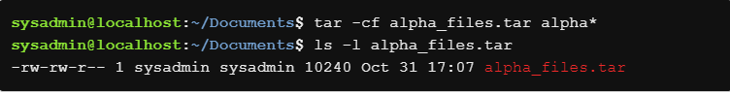

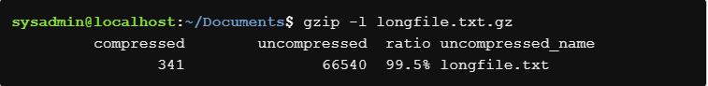Gzip- Compress or uncompress files.

Cut- Print selected parts of lines from each file to standard output.

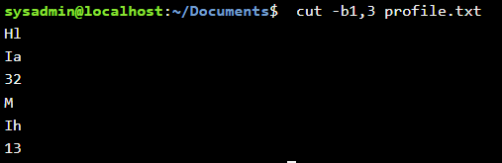

Wc- Print newline, word, and byte count for each FILE, and a total line if more than one FILE is specified.

Sh- Turns the terminal into bourne shell.



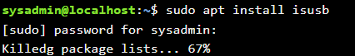Isusb

Ispci

Iscpu



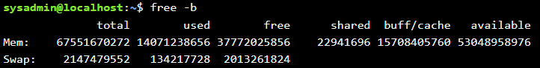Free

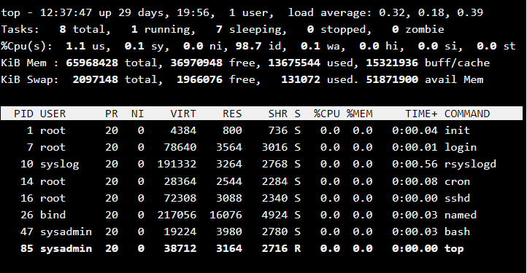Top

Pstree

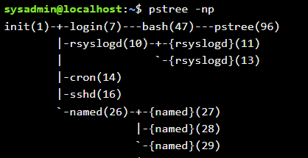

Ssh



Dig



Ss



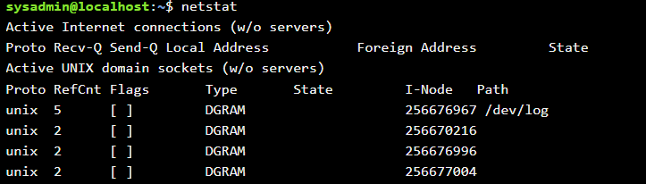Netstat

Ifup/Ifdown

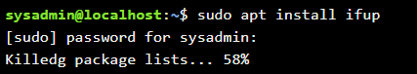

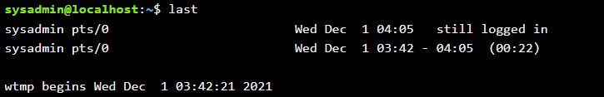Last

Who



Id

Umask



Chgrp

